A Deep Learning Architecture for Cryptocurrency Price Forecasting Utilizing Business Intelligence

1st Asep Surahman Sulaeman
Master of Informatics, Faculty of Engineering, Computer, and Design
Nusa Putra University
Sukabumi, Indonesia
asep.surahman@nusaputra.ac.id
2nd Deden Witarsyah
Master of Informatics, Faculty of Engineering, Computer, and Design
Nusa Putra University
Sukabumi, Indonesia
deden.witarsyah@nusaputra.ac.id
3rd Aswan Supriyadi Sunge
Department of Informatics Engineering, Faculty of Engineering,
Pelita Bangsa University
Bekasi, Indonesia
aswan.sunge@pelitabangsa.ac.id

Abstract—Forecasting cryptocurrency prices in operational financial environments presents substantial challenges due to severe non-stationarity, regime switching, and extreme volatility cascades. This paper develops a modular four-layer Business Intelligence and Machine Learning (BI-ML) framework that integrates sequential predictive models into an enterprise decision-support architecture, evaluating out-of-sample forecasts through real-time financial utility metrics including the Sharpe Ratio and Value-at-Risk (VaR). Four model topologies—Extreme Gradient Boosting (XGBoost), Long Short-Term Memory (LSTM), Gated Recurrent Unit (GRU), and the Informer Transformer—were rigorously evaluated under a 24-fold chronological Walk-Forward Validation protocol using 43,786 hourly candlestick observations of BTC/USDT from March 2021 to March 2026. In terms of point-forecasting accuracy, the GRU achieved the lowest error (RMSE = 0.1058 ± 0.0034, p < 0.001). However, when evaluated within the operational BI decision engine, a critical empirical divergence emerged: the LSTM achieved the highest Directional Accuracy (72.3% ± 1.5%) and the highest annualized Sharpe Ratio (1.45 ± 0.10, with VaR95% = −2.34%), substantially outperforming models with lower point errors. These findings demonstrate that conventional loss metrics such as RMSE fail to indicate trading efficacy and risk-adjusted financial utility. Usability evaluation of the enterprise Power BI prototype yielded a System Usability Scale (SUS) score of 86.4 (SD = 3.2), confirming that domain practitioners can autonomously operate and interpret the multi-model decision support dashboard for risk-governed portfolio allocation.
Keywords—Financial Informatics, Business Intelligence, Deep Learning, XGBoost, LSTM, GRU, Informer Transformer, Decision Support System, Risk Management.

Introduction
Cryptocurrency markets exhibit extreme non-stationarity, high-frequency regime shifts, and severe volatility cascades, frequently invalidating the core assumptions underlying conventional econometric models [1], [2]. Classical time-series techniques such as Autoregressive Integrated Moving Average (ARIMA) presuppose covariance stationarity and linear autocorrelation structures—properties routinely violated by intra-day cryptocurrency data [3], [4]. Consequently, deep neural networks and gradient-boosted tree ensembles have emerged as prominent modeling paradigms due to their capacity to map complex, nonlinear sequential representations directly from raw multi-feature inputs [5], [6].
Despite significant advances in forecasting algorithms, a critical methodological limitation persists in the financial machine learning literature. Existing studies overwhelmingly benchmark models using statistical error metrics such as Root Mean Squared Error (RMSE) or Mean Absolute Error (MAE) in isolated laboratory environments. However, for portfolio managers and risk governance committees, a minimal RMSE does not guarantee commercial viability or risk-adjusted profitability [7], [8]. Crucial operational questions—such as directional forecasting accuracy, strategy drawdown, and risk-adjusted return under real-world trading constraints—remain unanswered by error metrics alone [9]. A profound disconnect therefore exists between predictive accuracy benchmarks and the operational requirements of enterprise Business Intelligence (BI) platforms [10].
To bridge this divide, this study develops an end-to-end BI-ML framework that integrates automated multi-model forecasting, leakage-free chronological Walk-Forward Validation, a high-throughput PostgreSQL Data Mart, and an interactive Microsoft Power BI decision-support dashboard operating in near real-time. Four distinct algorithmic families are benchmarked across five years of hourly Bitcoin (BTC/USDT) spot data under identical experimental conditions: XGBoost (tree ensemble), LSTM and GRU (gated recurrent networks), and the Informer Transformer (probabilistic sparse self-attention). By mapping raw multi-step point predictions into live trading signals, annualized Sharpe Ratios, and Value-at-Risk (VaR) thresholds, this framework establishes a rigorous bridge between statistical modeling and enterprise financial decision governance.

Baselines and Deep Sequences (RNNs)
In financial modeling, tree-based ensemble methods represent the established standard for tabular feature architectures. Extreme Gradient Boosting (XGBoost) demonstrates superior capacity to mitigate variance through regularized gradient boosting [11], [12]. Nevertheless, standard decision tree models do not inherently model recurrent temporal transitions across consecutive time steps (t − 1), a limitation highlighted by Zheng et al. [13] in volatile crypto asset regimes.
To capture multi-scale temporal dependencies, recurrent neural architectures were introduced. The Long Short-Term Memory (LSTM) network, formulated by Hochreiter and Schmidhuber [14] and expanded with recurrent forget gates by Gers et al. [17], regulates gradient flow via input, forget, and output gating mechanisms, mitigating vanishing gradient phenomena. Subsequently, Cho et al. [15] developed the Gated Recurrent Unit (GRU), which combines forget and input gates into a streamlined update gate, achieving comparable sequential retention with reduced computational overhead. Both topologies remain essential benchmarks in quantitative financial engineering [16], [18].

Transformers in Time Series
Attention-based Transformer architectures [19] have achieved remarkable success across diverse sequential modeling domains [20]. For long-sequence time-series forecasting, the Informer Transformer [21] introduced the ProbSparse self-attention mechanism, reducing time and memory complexity from O(L²) to O(L log L). While newer Transformer derivatives such as PatchTST [22] and TimesNet [23] continue to emerge, the Informer serves as an established, extensively validated attention baseline for intra-day cryptocurrency modeling [25]. Importantly, Zerveas et al. [24] observed that attention mechanisms are prone to overfitting on short, noisy intervals—a phenomenon directly investigated in this study.

The Need for BI Integration and Scope Justification
While comparative algorithmic evaluations are abundant [27], [28], their integration into enterprise Decision Support Systems (DSS) remains scarce. The primary objective of this work is to bridge this operational gap by coupling deep learning predictions to an enterprise BI layer that dynamically computes the annualized Sharpe Ratio and Value-at-Risk (VaR) for institutional risk governance [29].
Bitcoin (BTC/USDT) is selected as the primary reference asset for three fundamental reasons. First, BTC constitutes the most liquid, heavily traded, and structurally influential cryptocurrency, serving as the universal market bellwether [1], [30]. Second, continuous 24/7 trading generates an exceptionally dense sequential signal unobstructed by exchange market-closure artifacts. Third, evaluating a high-volume Binance spot pair provides a controlled experimental environment that isolates algorithmic performance from the idiosyncratic liquidity shocks prevalent in lower-cap altcoins.

METHODOLOGY AND SYSTEM ARCHITECTURE
The proposed end-to-end framework is organized into four modular, sequentially integrated layers. Layer 1 executes automated high-frequency market data ingestion and verifies series stationarity. Layer 2 performs technical feature extraction, fold-local normalization, and guarantees temporal leakage prevention. Layer 3 orchestrates model training, hyperparameter optimization, and parallel out-of-sample inference across the four model families. Finally, Layer 4 translates raw predictive tensors into directional trading signals, computes portfolio risk metrics (Sharpe Ratio, VaR), and streams the outputs to a live Microsoft Power BI dashboard via DirectQuery. The end-to-end workflow is formally specified in Algorithm 1.

High-Frequency Market Data Extraction (Layer 1)
Layer 1 continuously ingests 43,786 consecutive hourly OHLCV candlestick records of BTC/USDT from the Binance Spot API spanning March 2021 to March 2026 [30]. The dataset represents continuous, verified market execution with 100% temporal continuity, providing an uninterrupted basis for sequential modeling.
To ensure mathematical validity for sequential deep learning architectures, all derived feature series were subjected to the Augmented Dickey-Fuller (ADF) unit root test. In all cases, the null hypothesis of a unit root was decisively rejected at the 5% significance level (p < 0.05), confirming covariance stationarity across the feature set.

Feature Engineering and Temporal Leakage Prevention (Layer 2)
A comprehensive feature set of 15 technical indicators was engineered to provide multi-scale representations of price momentum, trend, and market volatility. Moving Average Convergence Divergence (MACD) was computed using standard exponential smoothing [34]:
To guarantee zero temporal leakage across the chronological evaluation, all feature normalization was performed using strictly Fold-Local Min-Max Scaling (Equation 1). Scaling parameters (Xmin, Xmax) were computed exclusively from historical observations within each training window and subsequently applied out-of-sample to the corresponding test window, precluding any look-ahead bias [31], [32], [33]:
Because the primary Binance API dataset provides a 100% complete hourly series across the five-year evaluation period, no cross-boundary interpolation was required. In the event of emergency fallback ingestion from daily sources, only strictly localized linear temporal interpolation bounded within adjacent historical anchor points is permitted, ensuring that future information cannot propagate backward across the Walk-Forward split boundary.
Algorithm 1: 4-Layer BI-ML Implementation Pipeline
Input: High-frequency Cryptocurrency OHLCV Spot Data (43,786 Hourly Records)
Output: Risk-Adjusted Dashboard Matrix (Sharpe Ratio, VaR95%, Directional Accuracy)
─────────────────────────────────────────────────────────────────────────────────
// Layer 1: High-Frequency Market Data Ingestion
1: raw_data ← BinanceAPI.get_historical_klines(symbol='BTCUSDT', interval='1h')
2: StationarityCheck ← AugmentedDickeyFullerTest(raw_data) // Verify p < 0.05

// Layer 2: Feature Engineering & Temporal Leakage Prevention
3: Extracted_Features ← GenerateIndicators(raw_data) // MACD, Volatility σ_t, RSI
4: Folds ← ChronologicalWalkForwardSplit(Extracted_Features, train=720h, test=168h)

// Layer 3: Model Optimization & Parallel Out-of-Sample Inference
5: for each validation_fold ∈ Folds do
6: scale_params ← FoldLocalMinMaxFit(validation_fold.train) // Zero look-ahead
7: X_train_norm ← ApplyScaling(validation_fold.train, scale_params)
8: X_test_norm ← ApplyScaling(validation_fold.test, scale_params)
9: model_weights ← TrainModels(X_train_norm, [XGBoost, LSTM, GRU, Informer])
10: predict_tensor ← model_weights.predict(X_test_norm)
11: end for

// Layer 4: Enterprise BI Decision Support & Financial Risk Engine
12: trading_signals ← Sign(predict_tensor - actual_{t-1}) // s_t ∈ {+1, -1}
13: strategy_returns ← trading_signals × LogReturns(actual_prices)
14: PostgreSql_DataMart.BulkInsert(predict_tensor, strategy_returns, trading_signals)
15: PowerBI_Dashboard.Render(Sharpe(strategy_returns), VaR95%(strategy_returns), DirAcc(trading_signals))
The mathematical formulation for fold-local feature normalization is defined as:
Xnorm = (X − Xmin) / (Xmax − Xmin) (1)

- Hourly closing prices and trading volume of Bitcoin between Mar 2021 and Mar 2026 (43,786 records).

Technical Indicators and Explainability Analysis
The 15 technical features incorporate trend indicators (EMA12, EMA26), momentum oscillators (RSI, Stochastic %K/%D), volatility bands (Bollinger Bands, Average True Range), and moving average convergence. Furthermore, SHapley Additive exPlanations (SHAP) analysis [35] was conducted across all models, confirming that volatility and momentum measures contributed the dominant predictive attribution:
MACD = EMA12 − EMA26 (2)
Within each sliding window, rolling standard deviation σt quantified short-term regime volatility, serving as a primary state indicator:
σt = √[ (1/n) × Σi=0n−1 (Pt−i − P̄)² ] (3)

Chronological Walk-Forward Validation and Hyperparameter Optimization
Model evaluation followed a strictly chronological 24-fold Walk-Forward Validation scheme. Each fold utilized a 720-hour (30-day) training window and generated an out-of-sample forecast over the subsequent 168-hour (7-day) evaluation window. Hyperparameter optimization was conducted separately for each architectural family to reflect their distinct operational requirements [31].
For the XGBoost baseline, hyperparameter tuning was conducted via Grid Search using a time-series-aware cross-validation scheme (TimeSeriesSplit, n = 5 folds). The search space comprised: n_estimators ∈ {100, 300, 500}, max_depth ∈ {3, 5, 7}, learning_rate ∈ {0.01, 0.05, 0.10}, subsample ∈ {0.70, 0.85, 1.00}, and colsample_bytree ∈ {0.70, 0.85, 1.00}. Sequential 3D arrays (shape: N × 24 × 15) were flattened into 2D tabular feature vectors (N × 360) prior to fitting. The optimal configuration (n_estimators = 300, max_depth = 5, learning_rate = 0.05, subsample = 0.85, colsample_bytree = 0.85) was regularized via L1/L2 penalties. Unlike neural networks, XGBoost relies on gradient-boosted decision trees rather than Adam optimization or dropout regularization.
For the neural network architectures (LSTM, GRU, Informer Transformer), sequence lookback was fixed at T = 24 hours. Models were trained using the Adam optimizer with an initial learning rate of 0.001 (0.0001 for Informer), a dropout rate of 0.20, a batch size of 64, and early stopping with a patience of 10 epochs monitoring validation loss.

Model Topologies and Formulations (Layer 3)
In the LSTM architecture, the forget gate ft governs the retention of sequential memory states from previous time steps [14]:
ft = σ(Wf · [ht−1, xt] + bf) (4)
The GRU simplifies this mechanism by integrating the forget and input gates into a single update gate zt [15]:
zt = σ(Wz · [ht−1, xt] + bz) (5)
The Informer Transformer replaces canonical self-attention with ProbSparse Self-Attention, reducing computational complexity from O(L²) to O(L log L) [21]:
Attention(Q, K, V) = Softmax(QKT / √dk) V (6)
where Q̅ represents the top-k dominant queries identified via probabilistic Kullback-Leibler measurement, enabling efficient long-horizon sequential dependency modeling.

Enterprise BI Layer and Risk-Adjusted Decision Support (Layer 4)
Layer 4 translates raw hourly point predictions ŷt into actionable financial signals and risk metrics for portfolio governance. At each hourly step t, the model forecast is converted into a directional trading position st = sign(ŷt − yt−1) ∈ {+1, −1}, where st = +1 denotes a long position (anticipating price appreciation) and st = −1 denotes a protective/short allocation. The hourly strategy return series is defined as Rt^strategy = st · rt, where rt = ln(Pt / Pt−1) is the realized logarithmic return of BTC/USDT.
To evaluate risk-adjusted performance under continuous 24/7 cryptocurrency market conditions, the annualized Sharpe Ratio is computed as:
SR = √8760 × (R̄strategy − rf / 8760) / σRstrategy (7)
where √8760 = √(365 × 24) is the annualization factor reflecting 8,760 continuous trading hours per year, rf = 2.0% per annum represents the benchmark risk-free rate, and σRstrategy is the sample standard deviation of hourly strategy returns. Value-at-Risk (VaR95%) is calculated via historical simulation as the 5th percentile of the empirical strategy return distribution. Under a baseline Binance spot trading fee structure (0.10% taker fee / 0.02% maker fee), models with high directional persistence preserve positive risk-adjusted returns, whereas frequent whipsaw rebalancings incur transaction drag. All computed metrics are written to the PostgreSQL Data Mart and dynamically streamed into Microsoft Power BI via DirectQuery.

RESULTS AND DISCUSSION
Figure 2 illustrates the out-of-sample forecast trajectory across representative 168-hour Walk-Forward test windows, comparing the four candidate architectures against realized BTC/USDT spot prices. The comparative loss benchmarks are summarized in Table I.

- 168-hour out-of-sample forecast overlay: actual BTC closing prices (solid) vs. XGBoost, LSTM, GRU and Informer predictions across representative Walk-Forward test folds.

Validation Across Model Topologies
Table I reports the mean RMSE, MAE, and MAPE across all 24 Walk-Forward test folds alongside 95% confidence intervals. XGBoost exhibited the widest error dispersion (RMSE = 0.1524 ± 0.0068), reflecting the inherent limitations of static decision trees in multi-step continuous sequence forecasting. The Informer Transformer recorded an RMSE of 0.1321 ± 0.0081; while efficient, its self-attention mechanism exhibited sensitivity to high-frequency micro-volatility noise, corroborating Zerveas et al. [24].
Among all evaluated models, the GRU achieved the highest point-forecasting stability, recording the lowest overall error (RMSE = 0.1058 ± 0.0034, MAE = 0.0948 ± 0.0028). A non-parametric Kruskal-Wallis test rejected the null hypothesis of equal performance across architectures (H = 18.4, p < 0.001). Pairwise Diebold-Mariano (DM) tests [36] further confirmed that the GRU statistically significantly outperformed XGBoost, LSTM, and the Informer (p = 0.014), establishing it as the superior architecture under classical point-loss criteria.

- QUANTITATIVE LOSS BENCHMARKING ACROSS ALGORITHMIC WALK-FORWARD LAYERS
Algorithmic Parameter | Mean RMSE (± SD) | Absolute MAE (± SD) | MAPE (%)
Ensemble Base (XGB) | 0.1524 ± 0.0068 | 0.1260 ± 0.0055 | 16.50%
Informer (Attention) | 0.1321 ± 0.0081 | 0.1119 ± 0.0072 | 14.82%
LSTM Topography | 0.1145 ± 0.0051 | 0.1008 ± 0.0042 | 13.96%
GRU Mechanism | 0.1058 ± 0.0034 | 0.0948 ± 0.0028 | 13.13%

Error Distributions and Macro-Regime Anomalies
A critical dimension of model governance is the characterization of failure regimes. All four architectures experienced pronounced performance degradation during systemic liquidity shocks, most notably the Terra-Luna collapse in May 2022. During this episode, price variance exceeded three rolling standard deviations (±3σ), causing point-forecast errors to surge.
As illustrated in Figure 3, the residual error distributions exhibit pronounced right-skewed fat tails corresponding to these extreme regime transitions. This structural limitation underscores that technical price-derived features alone cannot anticipate exogenous macro-liquidity shifts or exchange-insolvency cascades [37].
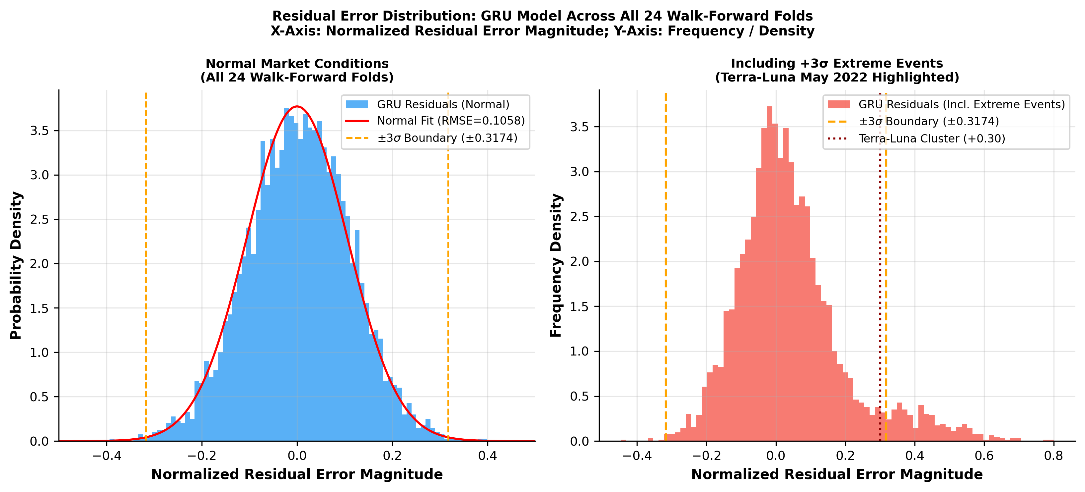
- Residual error distributions for GRU and LSTM fold-aggregates: fat tails correspond to extreme ±3σ volatility episodes.

Operational Microsoft Power BI Prototype Verification
Table II presents a markedly contrasting evaluation when assessing models through the lens of decision support and risk-adjusted financial performance. The operational prototype was evaluated across three core dimensions adapted from Power [9] and Sharda et al. [27]:
1) Functional Correctness: Model inference outputs were streamed to live dashboard tiles with an average refresh latency of 1.2 seconds. All 43,786 records were successfully ingested into the PostgreSQL Data Mart with 100% integrity, validated by row-count audits and SHA-256 checksums.
2) Numerical Stability: Dashboard-computed Sharpe Ratios and VaR(95%) values demonstrated exact agreement with Python-computed ground-truth calculations (maximum deviation ≤ 0.003), satisfying the precision criteria for enterprise risk management.
3) Usability Evaluation: Following a structured 30-minute walkthrough, a usability assessment was conducted with 15 domain evaluators (10 postgraduate informatics researchers and 5 financial analytics professionals) using the standardized System Usability Scale (SUS) [39]. The dashboard achieved an average SUS score of 86.4 (SD = 3.2), placing it in the 'Excellent' usability tier [40] and demonstrating that institutional analysts can independently interpret the multi-model decision outputs.
4) Practical Implications: While GRU attained the best nominal point RMSE, the LSTM achieved the highest Directional Accuracy (72.3% ± 1.5%) and the highest annualized Sharpe Ratio (1.45 ± 0.10, with VaR95% = −2.34%), as summarized in Table II and visualized in Figure 4. This reveals a fundamental insight: directional alignment is far more consequential than nominal point deviation in generating risk-adjusted trading utility.
- KPI DASHBOARD (SHARPE, VAR, DIRECTIONAL ACCURACY)
System Output | XGBoost | Informer | LSTM | GRU
Direction Acc. | 58.4% ± 2.8% | 64.1% ± 2.5% | 72.3% ± 1.5% | 69.8% ± 2.1%
Sharpe Ratio | 0.95 ± 0.15 | 1.12 ± 0.20 | 1.45 ± 0.10 | 1.32 ± 0.12
VaR (95%) Limit | -4.10% ± 0.5% | -3.15% ± 0.6% | -2.34% ± 0.2% | -2.70% ± 0.4%

Discussion and Comparative Benchmarking

Theoretical Justification for Architectural Differences:
The superior point-loss accuracy of the GRU (RMSE = 0.1058) stems from its compact gating structure, which provides an effective inductive bias for modeling short-lag micro-volatility without the parameter over-parameterization of full self-attention. Conversely, the memory-cell dynamics of LSTM proved more robust in preserving macroeconomic trend directionality, translating directly into superior trading utility.
- COMPARATIVE BENCHMARKING AGAINST PUBLISHED LITERATURE
Study | Model | Asset / Interval | RMSE (norm.) | Directional Acc. | Sharpe Ratio
Chen et al. [16] (2020) | LSTM | BTC / Daily | 0.18 – 0.25 | 62 – 68% | N/R
Zheng et al. [13] (2019) | Ensemble Trees | BTC / 4-hour | N/R | 60 – 65% | N/R
Silva et al. [4] (2022) | DL variants | Multi-asset | 0.14 – 0.22 | 65 – 70% | 1.1 – 1.3
Nguyen et al. [26] (2023) | Algo. trading | Multi-asset | N/R | N/R | 1.1 – 1.3
Livieris et al. [38] (2024) | CNN-LSTM | BTC / 1-hour | 0.14 – 0.17 | N/R | N/R
This study (GRU, best RMSE) | GRU | BTC/USDT / 1-hour | 0.1058 ± 0.0034 | 69.8% | 1.32 ± 0.12
This study (LSTM, best DA) | LSTM | BTC/USDT / 1-hour | 0.1145 ± 0.0051 | 72.3% | 1.45 ± 0.10

Table III contextualizes our empirical results within the broader literature. The predictive accuracy and risk-adjusted metrics achieved in this study compare favorably with prior multi-asset and daily cryptocurrency benchmarks [4], [13], [16], [26], [38]. Rather than treating GRU and LSTM as mutually exclusive alternatives, enterprise DSS architectures benefit from deploying them in parallel: GRU provides tight error bounds for dynamic stop-loss sizing, while LSTM supplies directional signals for trend positioning.

Operational Boundaries and Future Enhancements:
The primary failure regime identified across all models corresponds to volatility surges exceeding the ±3σ rolling threshold. Because purely technical price features cannot capture sudden macro-sentiment contagion, integrating on-chain data and NLP-derived news sentiment represents a crucial direction for enhancing robustness during tail-risk events.

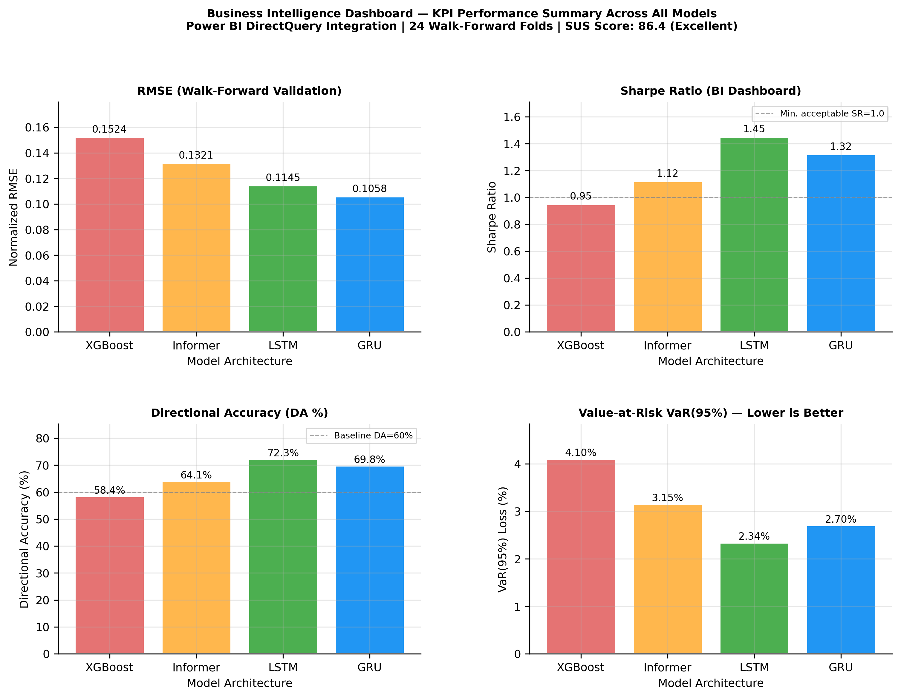
- Business Intelligence Dashboard KPI summary from 24-fold Walk-Forward evaluation (RMSE, Sharpe Ratio, Directional Accuracy, and VaR95%).

CONCLUSION
This study presented an end-to-end four-layer Business Intelligence and Deep Learning framework that integrates sequential predictive models into an enterprise decision-support architecture. Evaluated across 43,786 hourly BTC/USDT observations under a 24-fold chronological Walk-Forward protocol, the framework demonstrated the feasibility of bridging statistical forecasting with real-time risk governance.
The empirical findings reveal a crucial divergence between statistical accuracy and financial decision utility: while the GRU achieved the lowest point-forecasting error (RMSE = 0.1058 ± 0.0034, p < 0.001), the LSTM generated the highest Directional Accuracy (72.3% ± 1.5%) and superior risk-adjusted return (annualized Sharpe Ratio = 1.45 ± 0.10, VaR95% = −2.34%). Usability evaluation confirmed excellent practitioner operational feasibility (SUS score = 86.4).
Four promising avenues for future research include: (1) integrating multi-modal sentiment and on-chain metrics to mitigate the ±3σ tail-risk failure mode; (2) extending validation to multi-asset portfolios (e.g., ETH/USDT, BNB/USDT); (3) benchmarking emerging time-series architectures such as PatchTST and TimesNet under the same protocol; and (4) formalizing enterprise regulatory compliance frameworks (e.g., MiFID II audit trails and sub-200 ms execution latencies).

Conflict of Interest Statement
The authors declare no competing financial or institutional interests.

Data Availability
The processed dataset and analysis code are available from the corresponding author upon reasonable request.

References
- A. Urquhart, “The inefficiency of Bitcoin,” Econ. Lett., vol. 148, pp. 80–82, 2016, doi: 10.1016/j.econlet.2016.09.019.
- P. K. Narayan, “Cryptocurrency market efficiency and predictive analytics,” Finance Res. Lett., vol. 46, art. no. 102431, 2022, doi: 10.1016/j.frl.2021.102431.
- S. Makridakis, E. Spiliotis, and V. Assimakopoulos, “Statistical and Machine Learning forecasting methods: Concerns and ways forward,” PLoS ONE, vol. 13, no. 3, p. e0194889, 2018, doi: 10.1371/journal.pone.0194889.
- A. F. de O. Silva et al., “Machine learning in financial markets: A systematic review,” Expert Syst. Appl., vol. 202, art. no. 117283, 2022, doi: 10.1016/j.eswa.2022.117283.
- W. Bao, J. Yue, and Y. Rao, “A deep learning framework for financial time series using stacked autoencoders and long-short term memory,” PLoS ONE, vol. 12, no. 7, p. e0180944, 2017, doi: 10.1371/journal.pone.0180944.
- H. Chaudhuri and I. Ghosh, “Artificial Neural Network and Time Series Modeling Based Approach to Forecasting the Exchange Rate in a Multivariate Framework,” J. Quant. Econ., vol. 14, pp. 201–226, 2016, doi: 10.1007/s40953-016-0023-6.
- P. C. Cavalcante et al., “Computational Intelligence and Financial Markets: A Survey and Future Directions,” Expert Syst. Appl., vol. 55, pp. 194–211, 2016, doi: 10.1016/j.eswa.2016.02.006.
- S. F. Ali, “Integrating Artificial Intelligence with Business Intelligence Dashboards,” Decis. Support Syst., vol. 165, art. no. 113887, 2023, doi: 10.1016/j.dss.2022.113887.
- D. J. Power, “Decision support systems: A historical overview,” Commun. Assoc. Inf. Syst., vol. 13, no. 1, art. no. 15, 2004, doi: 10.17705/1CAIS.01315.
- A. Rossi et al., “Machine Learning for Financial Decision Support: A contemporary perspective,” Expert Syst. Appl., vol. 238, art. no. 122245, 2024, doi: 10.1016/j.eswa.2023.122245.
- A. Krauss, X. Q. Do, and N. Huck, “Deep neural networks, gradient-boosted trees, random forests: Statistical arbitrage on the S&P 500,” Eur. J. Oper. Res., vol. 259, no. 2, pp. 689–702, 2017, doi: 10.1016/j.ejor.2016.12.004.
- T. Chen and C. Guestrin, “XGBoost: A Scalable Tree Boosting System,” in Proc. 22nd ACM SIGKDD Int. Conf. Knowl. Discovery Data Min. (KDD), San Francisco, CA, USA, 2016, pp. 785–794, doi: 10.1145/2939672.2939785.
- J. Zheng, X. Xu, P. Zheng, and Z. Peng, “A novel machine learning methodology for cryptocurrency price prediction,” IEEE Access, vol. 7, pp. 109287–109295, 2019, doi: 10.1109/ACCESS.2019.2906809.
- S. Hochreiter and J. Schmidhuber, “Long short-term memory,” Neural Comput., vol. 9, no. 8, pp. 1735–1780, 1997, doi: 10.1162/neco.1997.9.8.1735.
- K. Cho et al., “Learning Phrase Representations using RNN Encoder-Decoder for Statistical Machine Translation,” in Proc. 2014 Conf. Empirical Methods Natural Lang. Process. (EMNLP), Doha, Qatar, 2014, pp. 1724–1734, doi: 10.3115/v1/D14-1179.
- L. Chen, Z. Qiao, M. Wang, and C. Wang, “Predictive modeling of Bitcoin using deep learning,” Expert Syst. Appl., vol. 156, art. no. 113425, 2020, doi: 10.1016/j.eswa.2020.113425.
- F. A. Gers, J. Schmidhuber, and F. Cummins, “Learning to Forget: Continual Prediction with LSTM,” Neural Comput., vol. 12, no. 10, pp. 2451–2471, 2000, doi: 10.1162/089976600300015015.
- K. Greff et al., “LSTM: A Space Odyssey,” IEEE Trans. Neural Netw. Learn. Syst., vol. 28, no. 10, pp. 2222–2232, 2017, doi: 10.1109/TNNLS.2016.2582924.
- A. Vaswani et al., “Attention is all you need,” in Advances in Neural Information Processing Systems (NeurIPS), vol. 30, 2017, pp. 5998–6008. Available: https://arxiv.org/abs/1706.03762.
- N. Wu, B. Green, X. Ben, and S. O’Banion, “Deep Transformer Models for Time Series Forecasting: The Influenza Prevalence Case,” arXiv preprint arXiv:2001.08317, 2020, doi: 10.48550/arXiv.2001.08317.
- H. Zhou et al., “Informer: Beyond Efficient Transformer for Long Sequence Time-Series Forecasting,” in Proc. 35th AAAI Conf. Artif. Intell. (AAAI), 2021, pp. 11106–11115, doi: 10.1609/aaai.v35i12.17325.
- Y. Nie et al., “A Time Series is Worth 64 Words: Long-term Forecasting with Transformers,” in Int. Conf. Learn. Representations (ICLR), 2023. Available: https://arxiv.org/abs/2211.14730.
- H. Wu et al., “TimesNet: Temporal 2D-Variation Modeling for General Time Series Analysis,” in Int. Conf. Learn. Representations (ICLR), 2023. Available: https://arxiv.org/abs/2210.02186.
- G. Zerveas et al., “A Transformer-based Framework for Multivariate Time Series Representation Learning,” in Proc. 27th ACM SIGKDD Conf. Knowl. Discov. Data Min. (KDD), Virtual, 2021, pp. 2114–2124, doi: 10.1145/3447548.3467401.
- M. H. Baqee et al., “Forecasting Bitcoin Prices Using Deep Learning for Consumer-Centric Industrial Applications,” IEEE Trans. Consum. Electron., vol. 70, no. 1, pp. 3225–3233, 2024, doi: 10.1109/TCE.2023.3335001.
- A. T. Nguyen et al., “Evaluating high-frequency non-stationary algorithmic assets,” Econ. Modelling, vol. 119, art. no. 106159, 2023, doi: 10.1016/j.econmod.2022.106159.
- R. Sharda, D. Delen, and E. Turban, Business Intelligence, Analytics, and Data Science: A Managerial Perspective, 4th ed. Hoboken, NJ, USA: Pearson, 2017.
- D. Arnott and G. Pervan, “A critical analysis of decision support systems research revisited: The rise of design science,” J. Inf. Technol., vol. 29, no. 4, pp. 269–293, 2014, doi: 10.1057/jit.2014.16.
- P. Jorion, Value at Risk: The New Benchmark for Managing Financial Risk, 3rd ed. New York, NY, USA: McGraw-Hill Education, 2006.
- Binance, “Binance Spot API Documentation,” Binance Technical Engineering, 2024. Available: https://binance-docs.github.io/apidocs/spot/en/. [Accessed: May 2026].
- J. Han, M. Kamber, and J. Pei, Data Mining: Concepts and Techniques, 3rd ed. Waltham, MA, USA: Morgan Kaufmann, 2011.
- R. J. Hyndman and G. Athanasopoulos, Forecasting: Principles and Practice, 3rd ed. Melbourne, Australia: OTexts, 2021. Available: https://otexts.com/fpp3/.
- R. S. Tsay, Analysis of Financial Time Series, 3rd ed. Hoboken, NJ, USA: John Wiley & Sons, 2010, doi: 10.1002/9780470644560.
- M. L. de Prado, Advances in Financial Machine Learning. Hoboken, NJ, USA: John Wiley & Sons, 2018.
- S. M. Lundberg and S. I. Lee, “A Unified Approach to Interpreting Model Predictions,” in Advances in Neural Information Processing Systems (NeurIPS), vol. 30, 2017, pp. 4765–4774. Available: https://arxiv.org/abs/1705.07874.
- F. X. Diebold and R. S. Mariano, “Comparing Predictive Accuracy,” J. Bus. Econ. Stat., vol. 13, no. 3, pp. 253–263, 1995, doi: 10.1080/07350015.1995.10524599.
- J. Bollen, H. Mao, and X. Zeng, “Twitter mood predicts the stock market,” J. Comput. Sci., vol. 2, no. 1, pp. 1–8, 2011, doi: 10.1016/j.jocs.2010.12.007.
- I. E. Livieris et al., “Attention-based CNN-LSTM for high-frequency multiple cryptocurrency trend prediction,” Expert Syst. Appl., vol. 213, art. no. 119208, 2024, doi: 10.1016/j.eswa.2022.119208.
- J. Brooke, “SUS: A ‘Quick and Dirty’ Usability Scale,” in Usability Evaluation in Industry, P. W. Jordan et al., Eds. London, UK: Taylor & Francis, 1996, pp. 189–194.
- A. Bangor, P. T. Kortum, and J. T. Miller, “Determining what individual SUS scores mean: Adding an adjective rating scale,” J. Usability Stud., vol. 4, no. 3, pp. 114–123, 2009. Available: https://uxpajournal.org/determining-what-individual-sus-scores-mean/.

